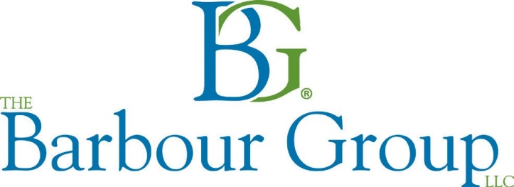
Fax completed request to 410-876-9954
Or
Email to: Info@thebarbourgroup.com
909 Baltimore Blvd, Westminster, MD 21157 | (410) 876-9610

Contract Surety Small Contractor Application
Single Bonds & Aggregate Limits up to $400,000 – Based on Personal Credit
Single Bonds & Aggregate Limits above $400,000 to $1,000,000 – Provide Most Current Year Personal and Company Tax Returns and Personal and Company In-House Statements (Accrual Based)

CONTRACTOR DATA |  |  |  |  |  | E-Mail Address
Type of Business: | Partnership |  | (S) Corp |  | (C) Corp |  |  | Sole Proprietorship |  |  |  |  | LLC
Company Name |  |  |  |  |  |  |  | Phone
Company Address
Type of Work |  |  |  |  |  |  |  |  | Date started in Business
Largest Contract Completed in last 3 years: |  |  |  | Contract Price |  |  |  |  |  |  |  | Gross Profit

OWNERS / INDEMNITORS DATA (Provide the information below on ALL owners & spouses; use additional sheets as necessary)
Name: |  |  |  |  |  |  |  |  |  |  | Name:
Address |  |  |  |  |  |  |  |  |  |  | Address
City/State/Zip |  |  |  |  |  |  |  |  |  |  | City/State/Zip
SS# |  |  |  |  |  |  | DOB |  |  |  | SS# |  |  |  |  |  | DOB
% of Business Ownership |  |  |  |  |  | Married |  | Yes | No |  | % of Business Ownership |  |  |  |  | Married |  |  | Yes | No
Spouse Name |  |  |  |  |  |  |  |  |  |  | Spouse Name
SS# |  |  |  |  |  |  | DOB |  |  |  | SS# |  |  |  |  |  | DOB

Please attach a sheet with an explanation for any “Yes” responses.
Have you ever been bonded before? (If yes, by whom and why are they not providing bonds for you now?) | Yes | No
Have you ever been in claim, and/or denied bonding by another surety? | Yes | No
Are you or any business in which you are involved, in litigation or is litigation pending? | Yes | No
Are any current jobs in dispute or have had liens filed against them? | Yes | No
Are you or any business in which you are involved currently delinquent in the payment of taxes? | Yes | No
Have you or any business you were involved with ever filed for bankruptcy? | Yes | No
Has this company or a prior company, any officer, owner or partner caused a loss or expense to a Surety? | Yes | No
By providing the above information, you consent to the Surety to order a credit report to be used in connection with the underwriting of this bond
and acknowledge that it is a crime to knowingly provide false, incomplete or misleading information to an insurance company for the purpose of defrauding the
company. Penalties may include fines, imprisonment and denial of benefits.

BOND REQUEST DATA |  |  | If no bond is needed at this time, but only prequalification for future bonding, check here
Anticipated Start Date |  |  |  |  | Time for Completion
Liquidated Damages |  |  |  |  | Maintenance Period
Obligee Name
Obligee Address
Job Description
Job Physical Location
Trades Subcontracted |  |  |  | Total Amount Subcontracted

Bid Bond |  |  |  |  | OR |  | Performance & Payment Bond
Bid Date |  |  |  |  |  |  | Contract Price
Estimated Bid Amount |  |  |  |  |  |  | Contract Date (date signed)
Engineers Estimate |  |  | None |  |  |  | Bid Secured by: Check Bond Negotiated
Bid Bond % or Amount |  |  |  |  |  |  | Next two lowest bidders
 |  |  |  |  |  |  | $ |  |  |  |  | $
Bond Form: | Surety Form |  |  | State Form (send copy) |  |  |  |  |  |  | Obligee Form (send copy)
 | AIA Form | Federal |  |  |  | Contract # |  |  |  |  |  |  | State of Incorp.

